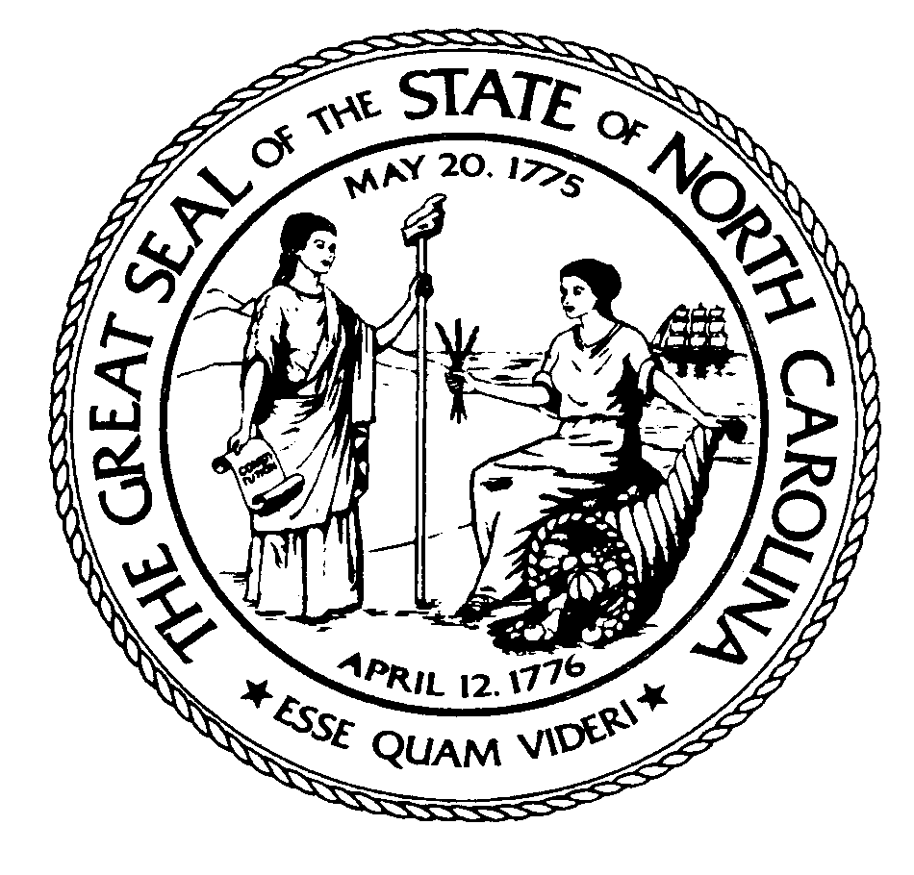

State of North Carolina

General Court of Justice

David Learner – District Attorney, 25th District

Burke – Caldwell – Catawba

**CATAWBA COUNTY JUSTICE CENTER**

**100 GOVERNMENT DRIVE, NEWTON, N.C. 28658-0566**

**PHONE: (828) 695-6110**

## **For Immediate Release 7/26/18**

***Following is a statement from District Attorney David Learner pertaining to the***

***officer-involved shooting of Kerry Edwin Townsend that occurred on July 17, 2018.***

On the afternoon of Tuesday, July 17, 2018, Mr. Kerry Edwin Townsend died during an officer-involved shooting incident that occurred on Zack’s Fork Road in Caldwell County, N.C.

I have carefully reviewed all available evidence pertaining to this matter. The purpose of my review was to determine whether the shooting of Mr. Townsend by law enforcement officers was lawful or unlawful.

The N.C. State Bureau of Investigation (SBI) investigated the above-referenced shooting. The SBI expended a considerable amount of time interviewing the witnesses (both law enforcement and civilian), photographing the scene, collecting items of physical evidence and securing the body camera footage from officers that were present.

The law enforcement officer statements, civilian witness interviews, photographs and physical evidence were consistent. I spent a substantial amount of time personally reviewing the video-taped interviews, photographs, body camera footage and other evidence submitted to me by the SBI. In addition, I observed the wounds to Mr. Townsend’s body. After a review of the evidence in this case, the following facts are apparent:

* Mr. Townsend had a lengthy prior criminal history, which included numerous acts of violence;
* On Sunday, July 15, 2018, Mr. Townsend attempted to murder Caldwell County Sheriff’s Deputy Jordan Sherrill by shooting Deputy Sherrill during a traffic stop;
* This assault occurred suddenly, with no warning and without any provocation;
* An extensive multi-county manhunt was under way to arrest Mr. Townsend;
* Although not 100 percent certain that Townsend was in the vacant residence on Zack's Fork Road, law enforcement had information that Mr. Townsend might be present, and, if so, he had shot and attempted to kill a law enforcement officer less than 48 hours earlier;
* Law enforcement officers had information that Townsend had been seen earlier in the day in the same vicinity on Zack’s Ford Road and that he was armed with a handgun at that time;
* At the time of entering the residence, members of the Caldwell County Sheriff’s Office SWAT Team clearly, loudly and repeatedly announced their identity as law enforcement officers;
* Mr. Townsend concealed himself within the house, and suddenly and without warning pulled up his arm and pointed a handgun at SWAT Team members;
* SWAT Team members immediately engaged Mr. Townsend and fired their weapons at him until he dropped the gun;
* The handgun was secured, and Mr. Townsend was immediately evacuated from the residence and given advanced first aid in an effort to save his life;
* The entire sequence of events, from the time Townsend attempted to shoot SWAT Team members until the shooting ended, unfolded in just a few seconds.

The United States Supreme Court has addressed the question of the reasonableness of police officers’ use of force. The Court has said, “Reasonableness must embody allowance for the fact that police officers are often forced to make split second judgments ­- in circumstances that are tense, uncertain and rapidly evolving ­­- about the amount of force that is necessary in a particular situation.” *Graham v. Connor, 490 UP.S. 386, 387-98 (1989)*

The law in North Carolina recognizes the principle of self-defense, which is the inherent right to use deadly force to protect one’s self or others from death or great bodily harm.

Therefore, based upon applicable law and the facts as reported by eyewitness accounts, corroborated by body camera videos, photographs and the physical evidence, it is my conclusion that the Caldwell County Sheriff's Office SWAT Team officers acted lawfully in shooting Mr. Townsend on July 17, 2018.

*David Learner, District Attorney (Caldwell, Burke and Catawba counties)*

**CONTACT: Nathan Key**

**Phone: 828-695-6193**

**Email: Nathan.D.Key@nccourts.org**